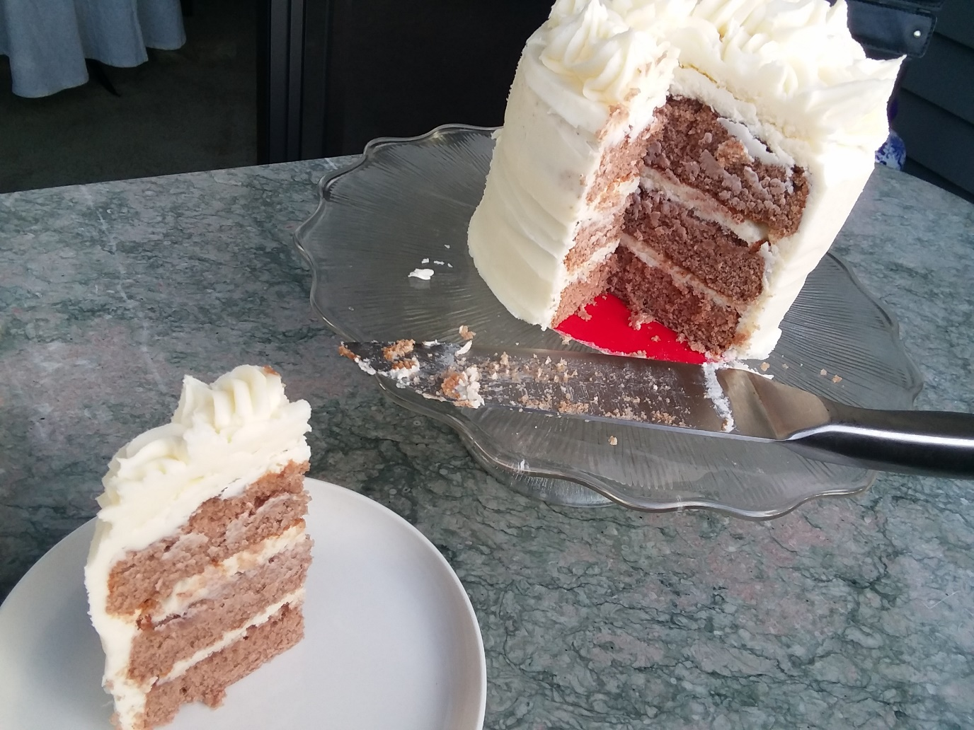
Spice Cake

- 3 Cups Flour
- 1 TB Baking Powder
- ½ tea Salt
- 1 ½ tea Cinnamon
- ½ tea Nutmeg, Allspice, Ginger, and Cloves
- 1 TB Cocoa Powder

- 1 Cup Butter
- 2 Cups Sugar
- 4 Eggs
- 1 cup Milk
- 1 tea Vanilla

